Optical Smoke Detector

Chor(connectable) / Chor-E(System Powered)
Optical Smoke Detectors react best on smoke from smouldering fire. It is recommended to install minimum one detector of this type outside each bedroom..Other rooms should also be protected. The advantages with this detector is that it can be either connected together with all detectors of this type in the house and thereby get the function : Alarm in ONE Alarm in ALL ! or it can be connected to our IMC-ME micro Fire Panel for increased protection !
Install 0,5m from walls. Min. 1m from flouricent light, “down lights” transformers for dimmers or other electronical disturbances. Avoid places with high velocity and humidity i.e. close to ventilators, air-con units etc.  In lounge, sitting rooms etc. the smoke detectors should be installed preferable in the middle of the ceiling. In bedrooms 1,5m from doors and in kitchen as far as possible away from stove and dishwasher.  The Detector is influenced by dust, pollen, damp and smoke from the stove. Install it in a location where these factors are at a minimum. Vacuum clean the detector annually.  Installation:  Place the cables in the middle of the socket, Make larger openings if necessary. Fix the socket in the ceiling.. Connect the wires and make sure the polarity is correct. Place the detector in the socket and turn it clockwise!  Cable:  Use min. 2 wired screened and twisted Cable d>=0,6mm.(I.e. Type 4AF22 or FFC 2x0,75). Use multitreaded wires to avoid breakage when connecting. The screen must be connected to 0V in all detectors and to loop – in IMC-ME.. | 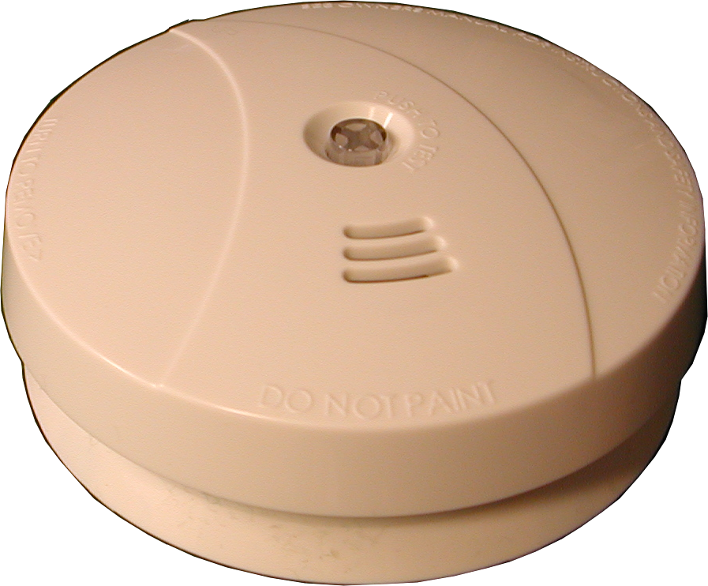  Specification:  Approval: EN 54-4, DBE  Detection Principle: Optical/Photoelectric  Power supply Chor: 9V battery  Power supply Chor-E: External 9V ,( IMC-ME)  Consumption < 12uA  Sounder: 85 dB(A) / 3m  Indication normal state: Blink every 45 sec.  Indicating alarm: Blink every sec.  Temp. area: 0°C - 50°C  Humidity: 95%RH  Dim. (w/socket): Ø=110mm, H=40mm
Chor is powered with 9V battery. There can be connected a max. of 8 Chor detectors in a group. When ALARM it will trigger all detectors in the group. Remember to connect the Battery in each detector!  1 = +9V  2 – 0V  1 = +S  2 = 0V | Chor-E is powered from our IMC-ME, Micro Fire Panel. This panel has two loops. 8 Chor-E detectors can be connected to each loop. In ALARM the Fire Panel can be set to trigger alarm in all detectors in the same loop as well as external Fire bell.
Chor Chor Chor

